**Here's how to download a .zip archive of your child's Seesaw journal, including images, videos, audio recordings, and text notes or captions.**

**Students who sign into Seesaw using their email address can also download their .zip archive by following these instructions.**

1. Sign into your Parent account at [https://app.seesaw.me](https://app.seesaw.me/)
2. Click on your Profile Icon on the top left
3. Click on the Gear Icon
4. Click on Account Settings
5. Click on Download Journal Archives
6. Click on the Download Zip button to download the archive to your computer.

**Step 1:** Sign into your parent account at [https://app.seesaw.me](https://app.seesaw.me/).

**Step 2:** Click on your Profile Icon on the top left

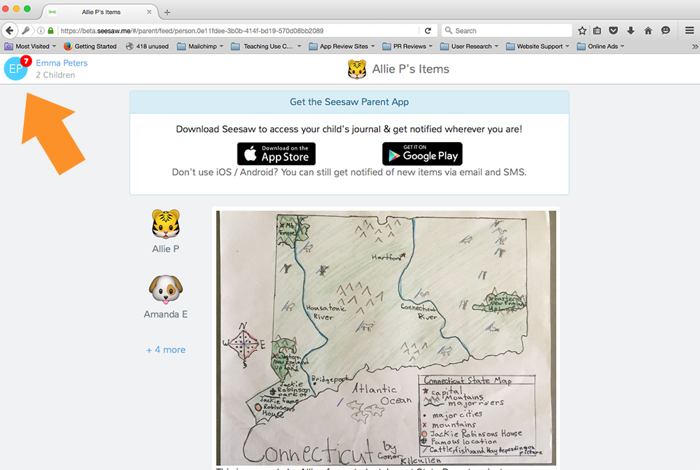

**Step 3:** Click on the Gear Icon

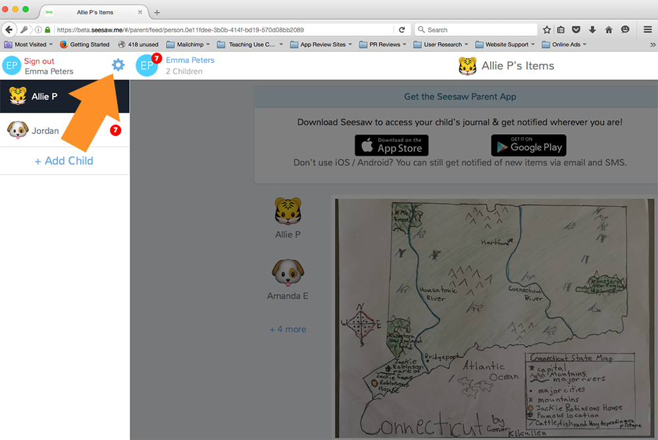

**Step 4:** Click on Account Settings

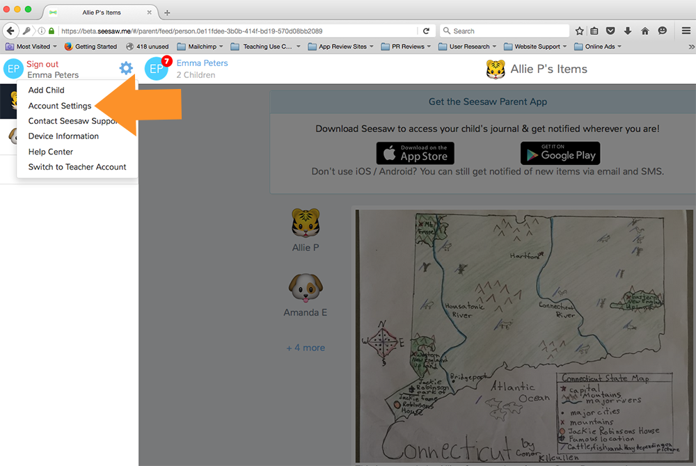

**Step 5:** Scroll down and click on Download Journal Archives

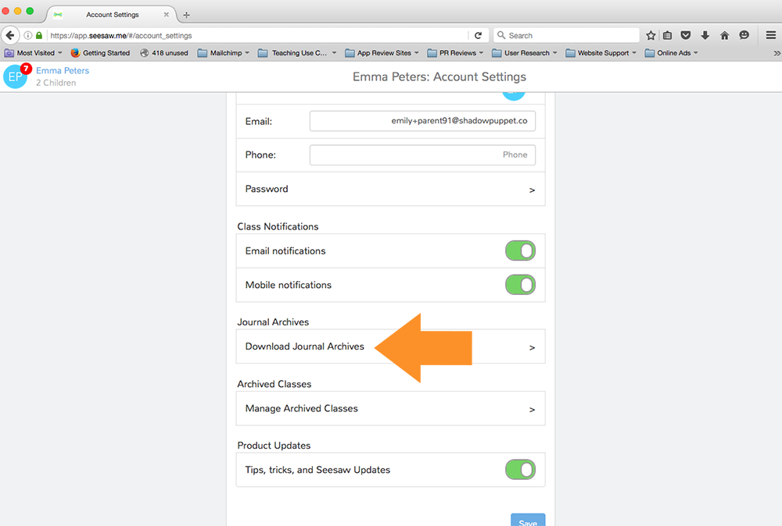

**Step 6:** Click on the Download Zip button for the journal you want to download. This might take a while depending on your Internet speed and how many posts your child has in Seesaw.

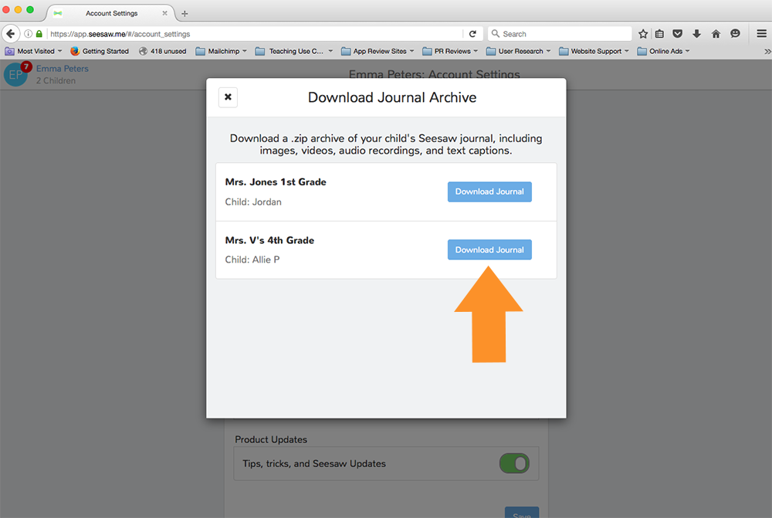

**This is what you get!** It is organized by month and then ordered by the date the post was added. You'll see an html file with a thumbnail, text notes or captions, folder names and links (if the post used the Link item type). You'll also see the original image, video or audio files.

